**Project 9:**

**IAM**

Task 1: Creating users without permissions-IAM password policy check.

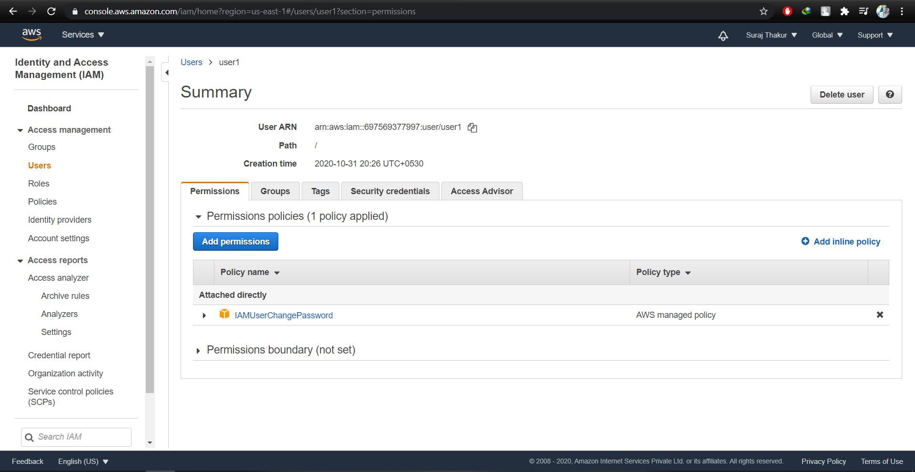

Task 2: Creating users without the IAM password policy.

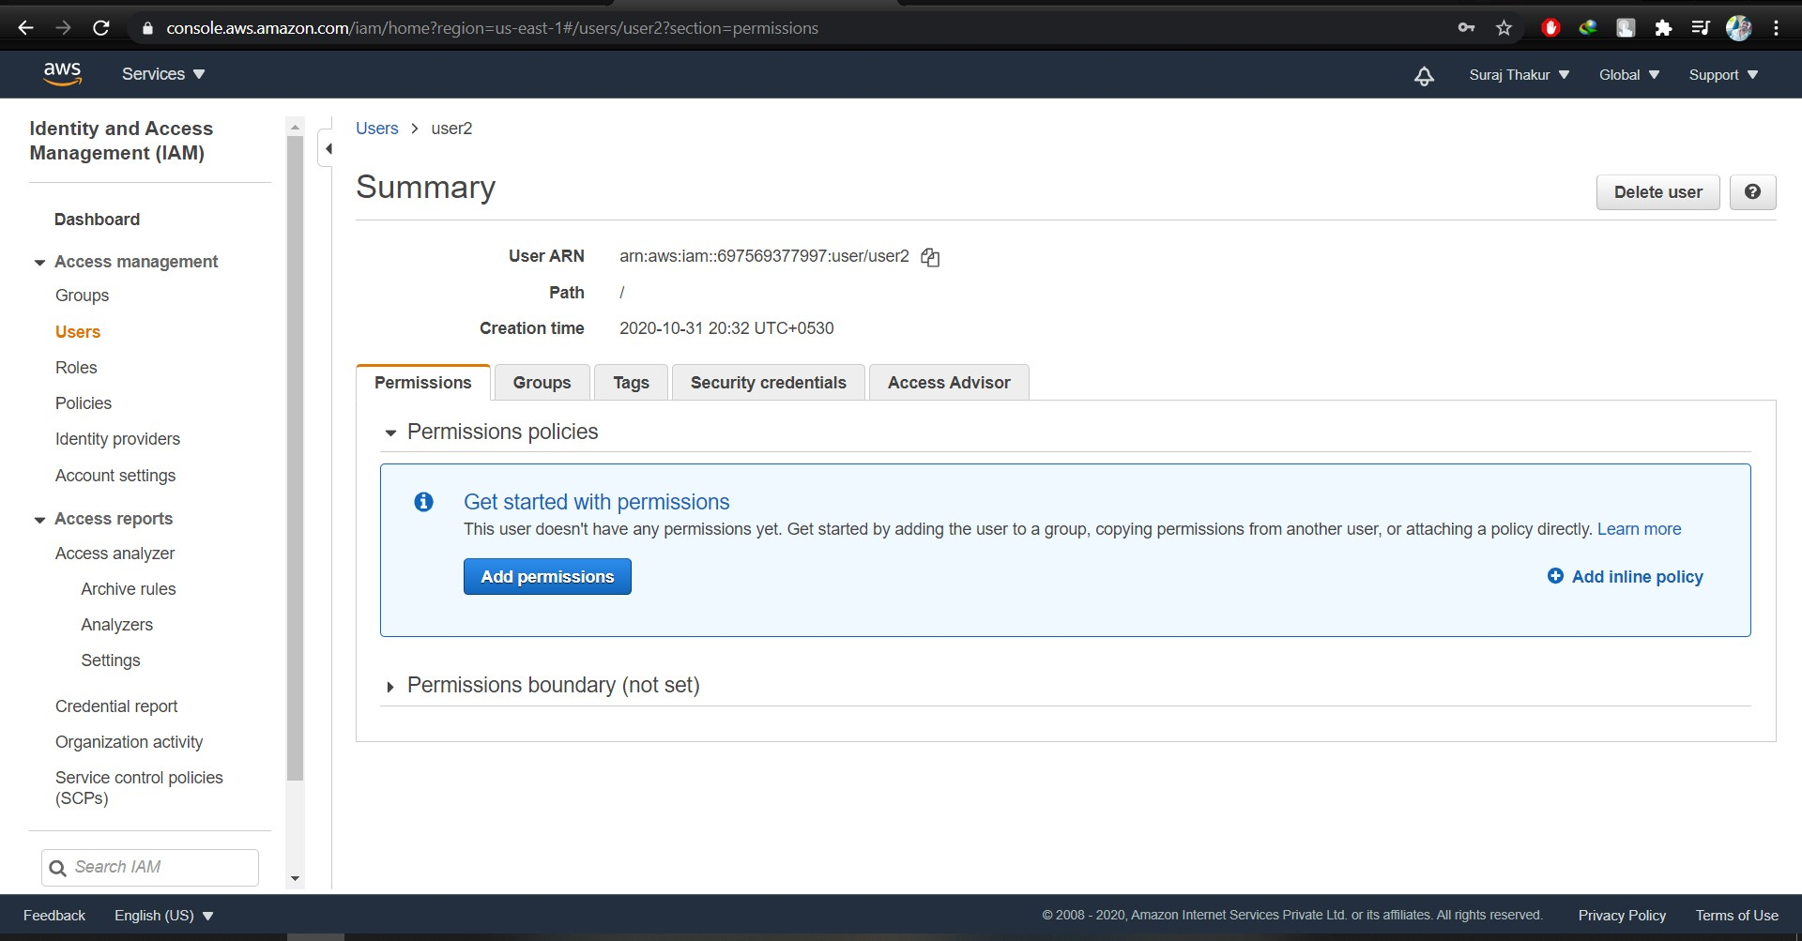

Task 3: Create a user with S3 full access

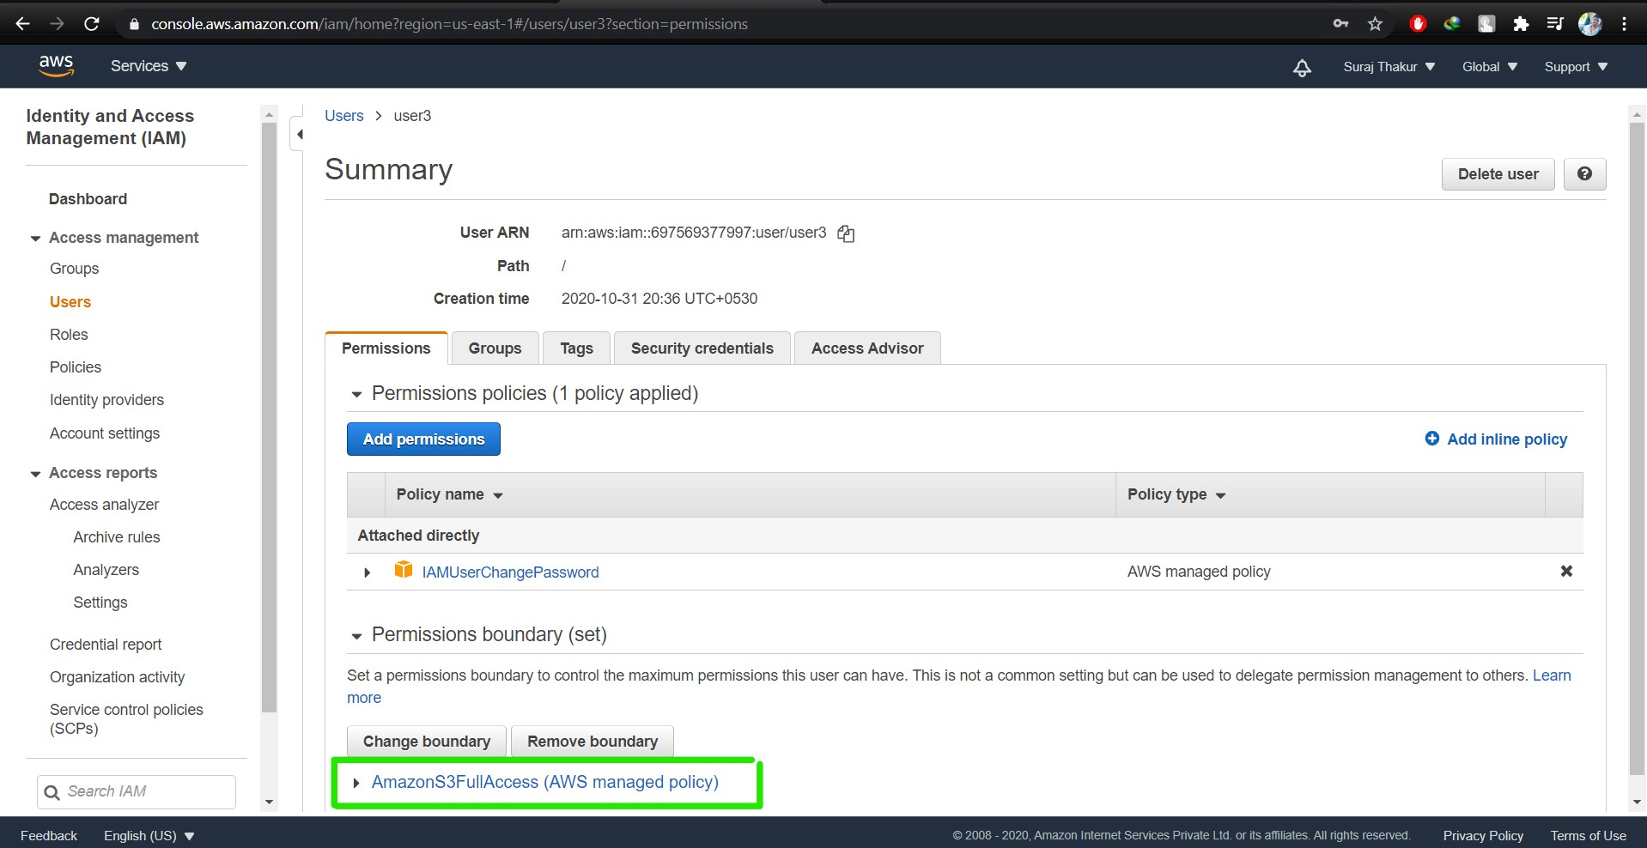

Task4: Create a group with ec2 full access

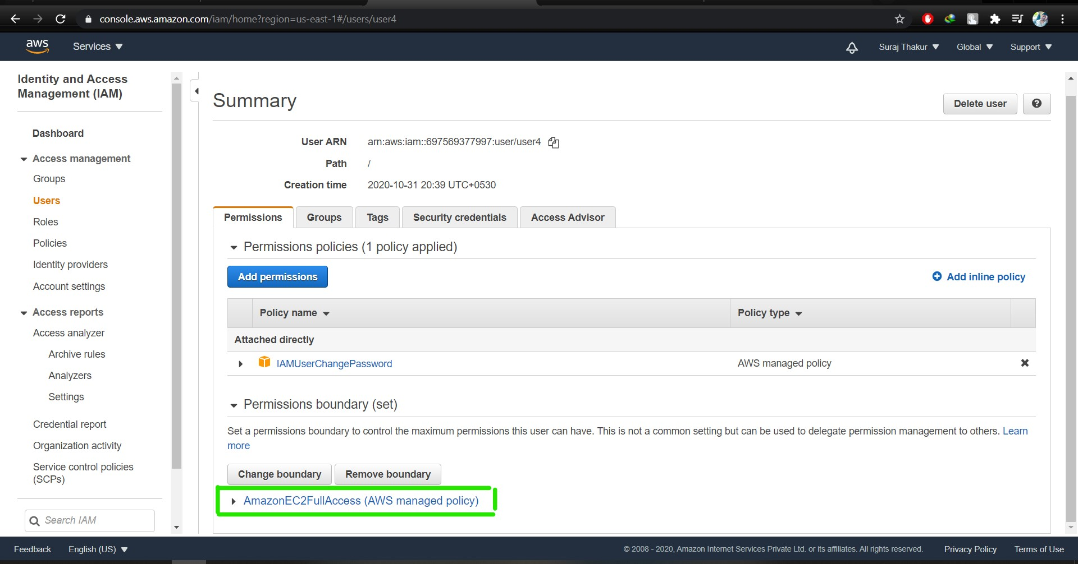

Task 5: Add user to a group and check if user policy and the group policy is reflecting on the user

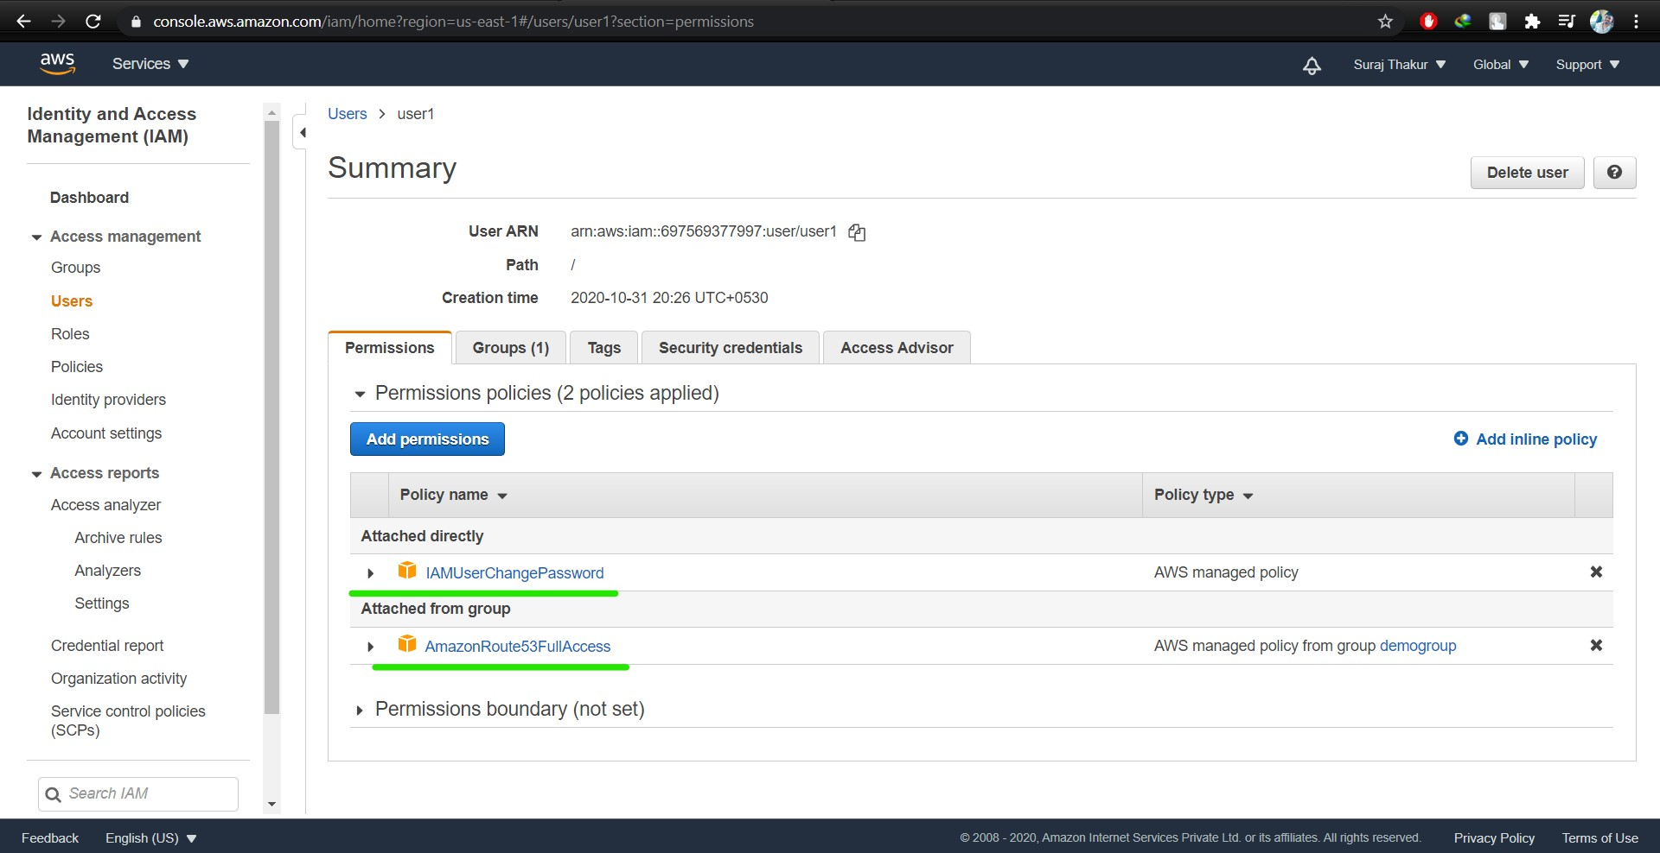

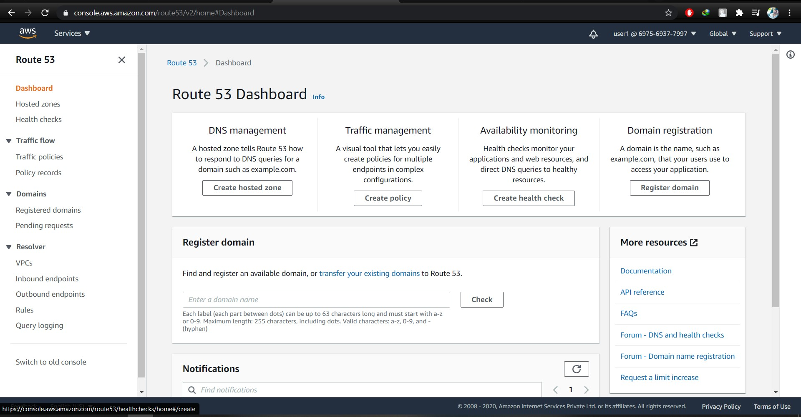

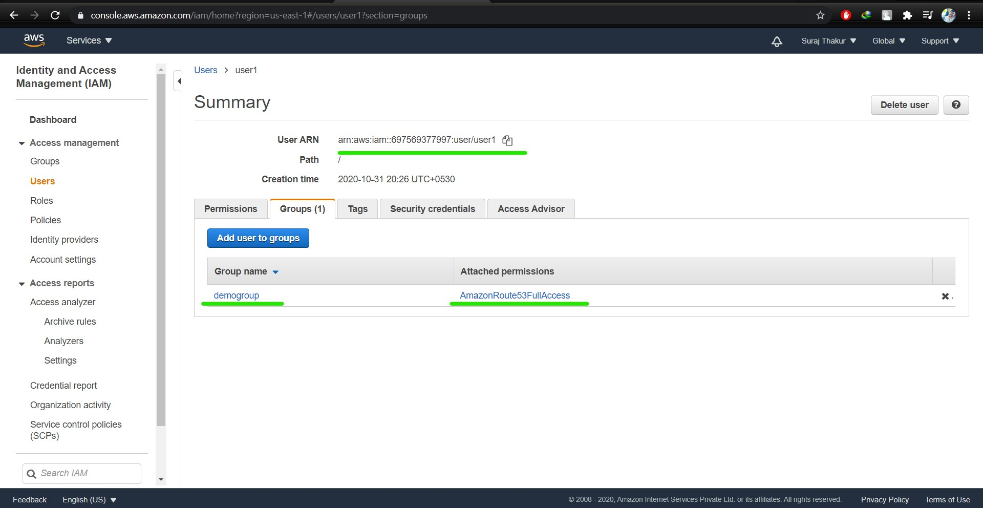

Task 6: Copy policies from the existing user

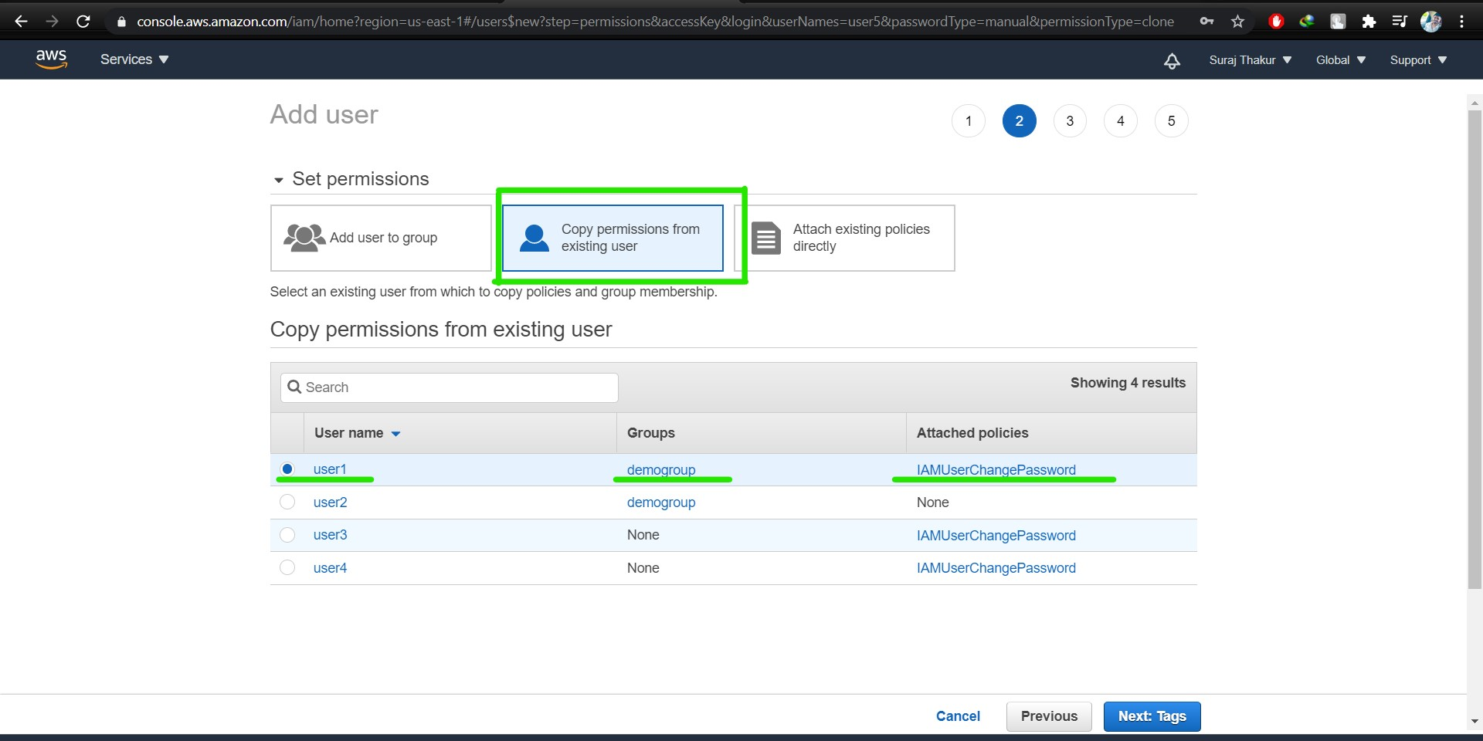

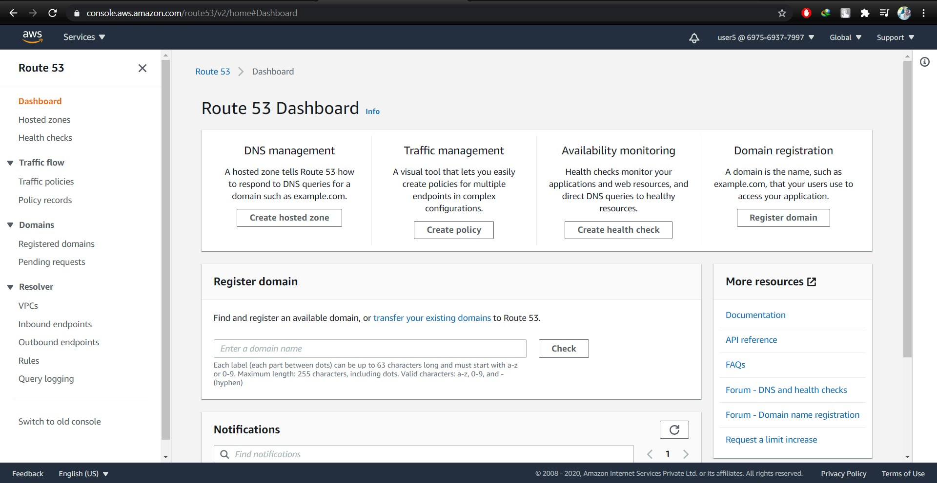

Task 7: Add user to a group in the process of creating a user

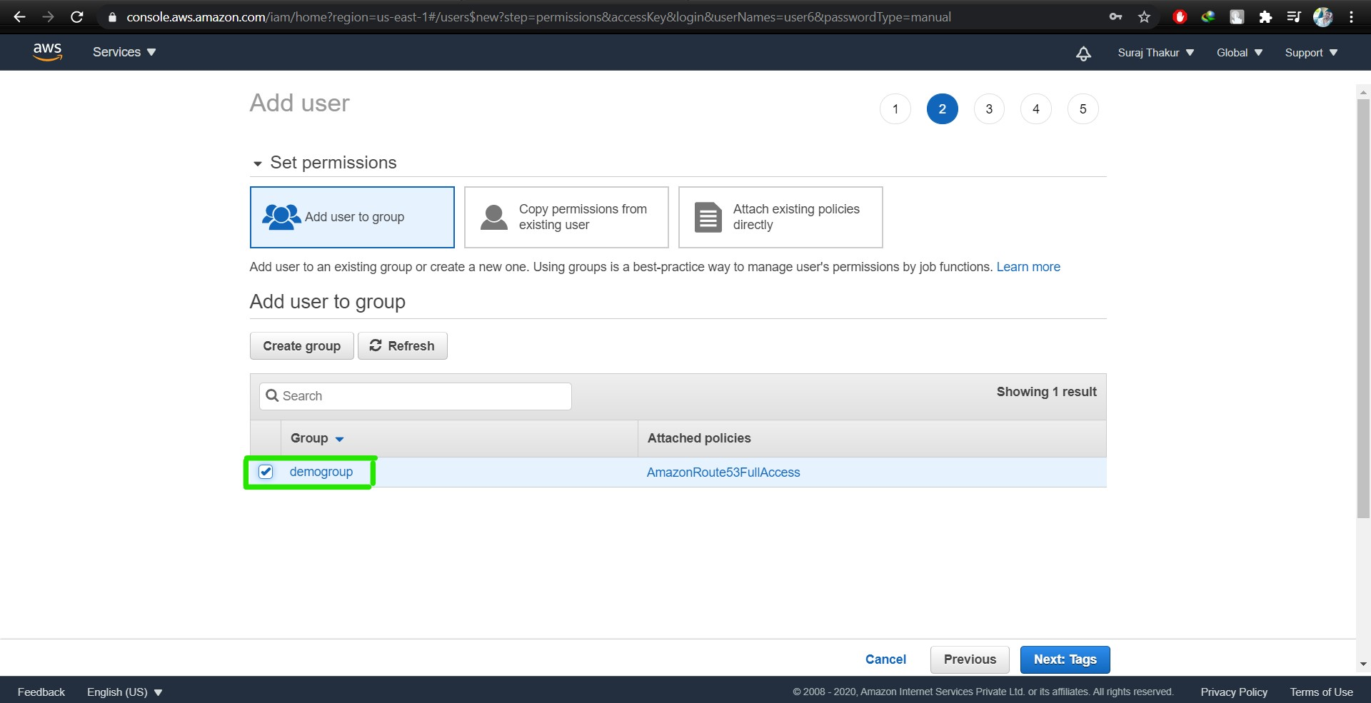

Task8: setting a password policy

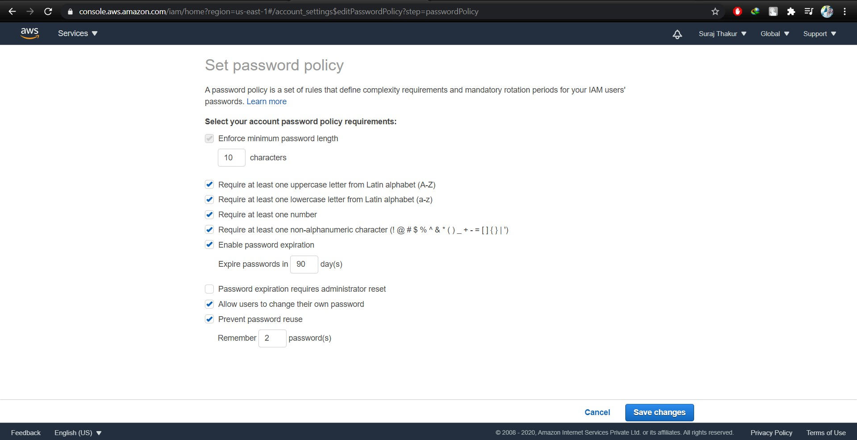

Logging as a user and we get password incompatibility error:

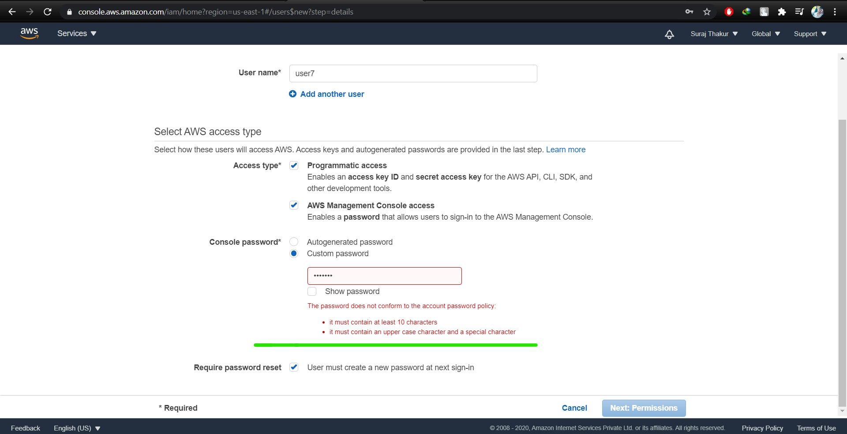

Task 9: Enabling MFA and using an MFA device

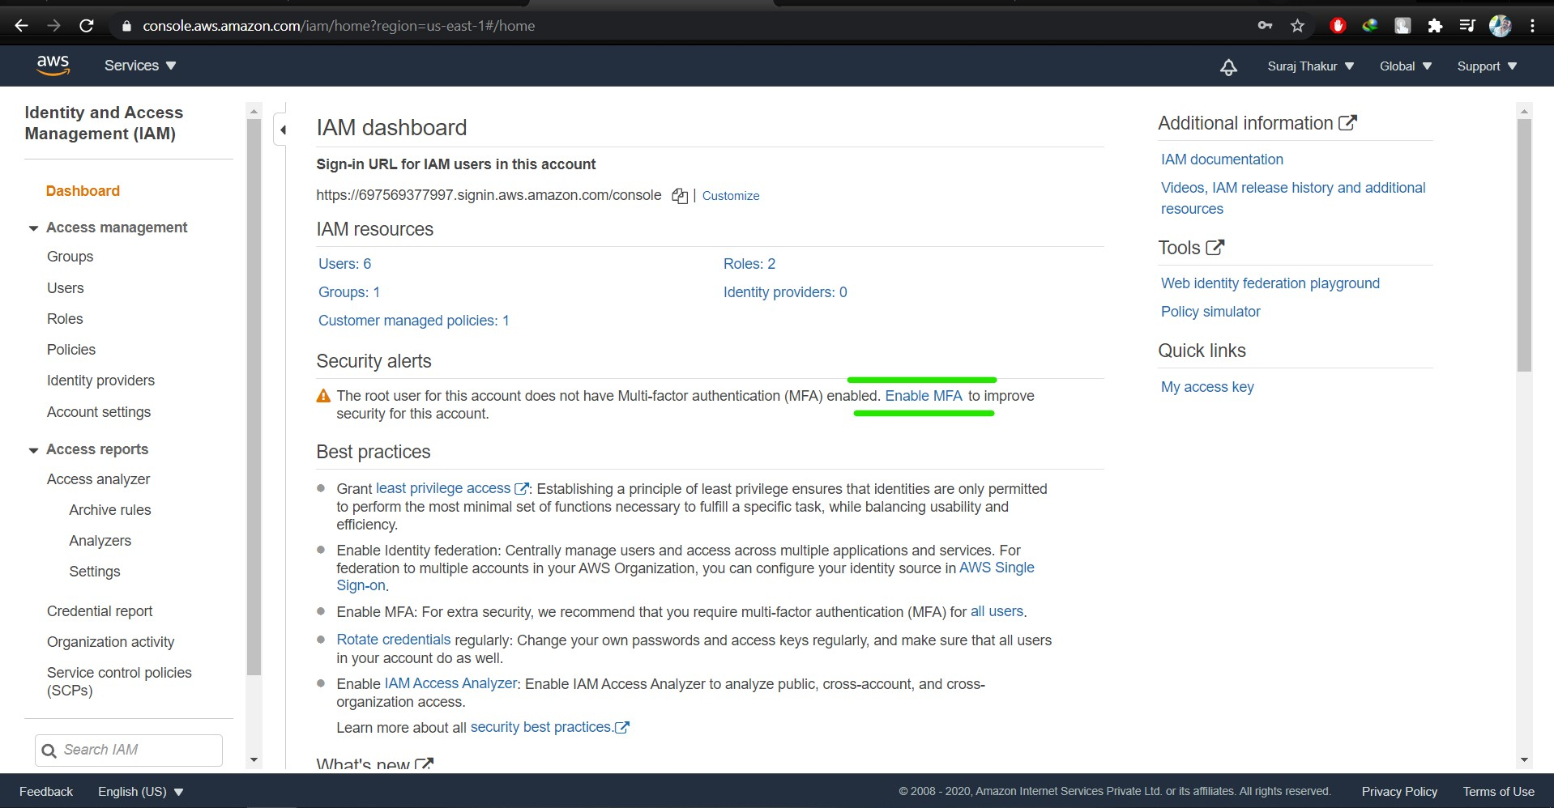

Login screen for MFA:

